Assignment - 4  
 Ultrasonic sensor simulation  
 In Wokwi

**PROJECT NAME: SMART SOLUTIONS FOR RAILWAYS**

**TEAM ID: PNT2022TMID11445**  
**Code:**

#include <WiFi.h>  
#include <PubSubClient.h>  
void callback(char* subscribetopic, byte* payload, unsigned int  
payloadLength);  
//-------credentials of IBM Accounts------  
#define ORG "ytluse"  
#define DEVICE_TYPE "2702"  
#define DEVICE_ID "12345"  
#define TOKEN "O+n)Eh+lNX0y3?rG!8" /  
String data3;  
char server[] = ORG ".messaging.internetofthings.ibmcloud.com";  
char publishTopic[] = "iot-2/evt/Data/fmt/json";  
char subscribetopic[] = "iot-2/cmd/test/fmt/String";  
char authMethod[] = "use-token-auth";  
char token[] = TOKEN;  
char clientId[] = "d:" ORG ":" DEVICE_TYPE ":" DEVICE_ID;  
WiFiClient wifiClient;  
PubSubClient client(server, 1883, callback ,wifiClient);  
const int trigPin = 5;  
const int echoPin = 18;  
#define SOUND_SPEED 0.034  
long duration;  
float distance;  
void setup() {  
Serial.begin(115200);  
pinMode(trigPin, OUTPUT);  
pinMode(echoPin, INPUT);  
wificonnect();  
mqttconnect();  
}  
void loop()  
{  
digitalWrite(trigPin, LOW);  
delayMicroseconds(2);  
digitalWrite(trigPin, HIGH);  
delayMicroseconds(10);  
digitalWrite(trigPin, LOW);  
duration = pulseIn(echoPin, HIGH);  
distance = duration * SOUND_SPEED/2;

Serial.print("Distance (cm): ");  
Serial.println(distance);  
if(distance<100)  
{  
Serial.println("ALERT!!");  
delay(1000);  
PublishData(distance);  
delay(1000);  
if (!client.loop()) {  
mqttconnect();  
}  
}  
delay(1000);  
}  
void PublishData(float dist) {  
mqttconnect();  
String payload = "{\"Distance\":";  
payload += dist;  
payload += ",\"ALERT!!\":""\"Distance less than 100cms\"";  
payload += "}";  
Serial.print("Sending payload: ");  
Serial.println(payload);  
if (client.publish(publishTopic, (char*) payload.c_str())) {  
Serial.println("Publish ok");  
} else {  
Serial.println("Publish failed");  
}  
}  
void mqttconnect() {  
if (!client.connected()) {  
Serial.print("Reconnecting client to ");  
Serial.println(server);  
while (!!!client.connect(clientId, authMethod, token)) {  
Serial.print(".");  
delay(500);  
}  
initManagedDevice();  
Serial.println();  
}  
}  
void wificonnect()  
{  
Serial.println();  
Serial.print("Connecting to ");  
WiFi.begin("Wokwi-GUEST", "", 6);  
while (WiFi.status() != WL_CONNECTED) {  
delay(500);  
Serial.print(".");  
}  
Serial.println("");  
Serial.println("WiFi connected");  
Serial.println("IP address: ");  
Serial.println(WiFi.localIP());

}  
void initManagedDevice() {  
if (client.subscribe(subscribetopic)) {  
Serial.println((subscribetopic));  
Serial.println("subscribe to cmd OK");  
} else {  
Serial.println("subscribe to cmd FAILED");  
}  
}  
void callback(char* subscribetopic, byte* payload, unsigned int payloadLength)  
{  
Serial.print("callback invoked for topic: ");  
Serial.println(subscribetopic);  
for (int i = 0; i < payloadLength; i++) {  
//Serial.print((char)payload[i]);  
data3 += (char)payload[i];  
}  
Serial.println("data: "+ data3);  
data3="";  
}  
Diagram.json:  
{  
"version": 1,  
"author": "RACHITHA",  
"editor": "wokwi",  
"parts": [  
{"type": "wokwi-esp32-devkit-v1", "id": "esp", "top": 6, "left": -66, "attrs": {} },  
{"type": "wokwi-hc-sr04", "id": "ultrasonic1", "top": 32.56, "left": 81.02, "attrs": {} }  
],  
"connections": [  
["esp:TX0", "$serialMonitor:RX", "", [] ],  
["esp:RX0", "$serialMonitor:TX", "", [] ],  
["esp:VIN", "ultrasonic1:VCC", "red", [ "h-31.67", "v-176.8", "h152", "v163.33" ] ],  
["esp:D18", "ultrasonic1:ECHO", "green", [ "h11.37", "v64.67", "h121.33" ] ],  
["esp:D5", "ultrasonic1:TRIG", "green", [ "h16.7", "v45.07", "h4" ] ],  
["esp:GND.1", "ultrasonic1:GND", "black", [ "h8.7", "v14.7", "h138.67" ] ]  
]  
}

**OUTPUT:**

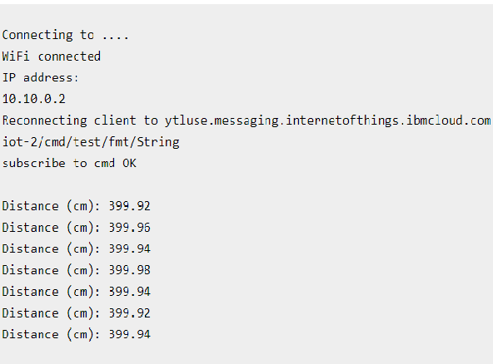

**CIRCUIT:**

